#1

This screenshot illustrates me clicking the 4th star out of 5 for the rating system on the web goat page. This sent a http request through the burp suite application.

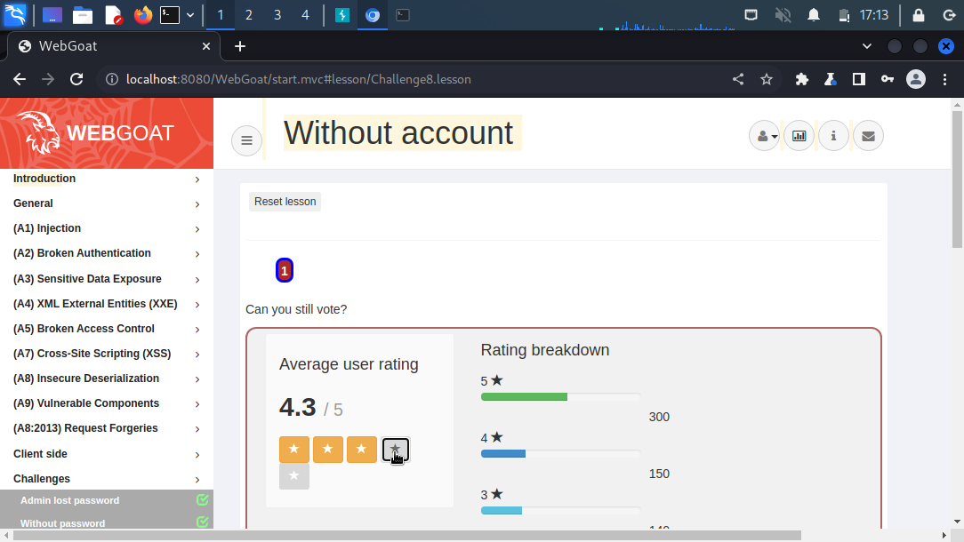

#2

This screenshot shows the http request being intercepted. By changing the request type to HEAD, it allowed the request to be sent through which allowed me to see the challenge flag from the repeater section of burpsuite.

#3

This screenshot illustrates that the flag you saw in the previous screenshot works correctly as it is supposed to and that I did not mess up the lab in any way shape or form.